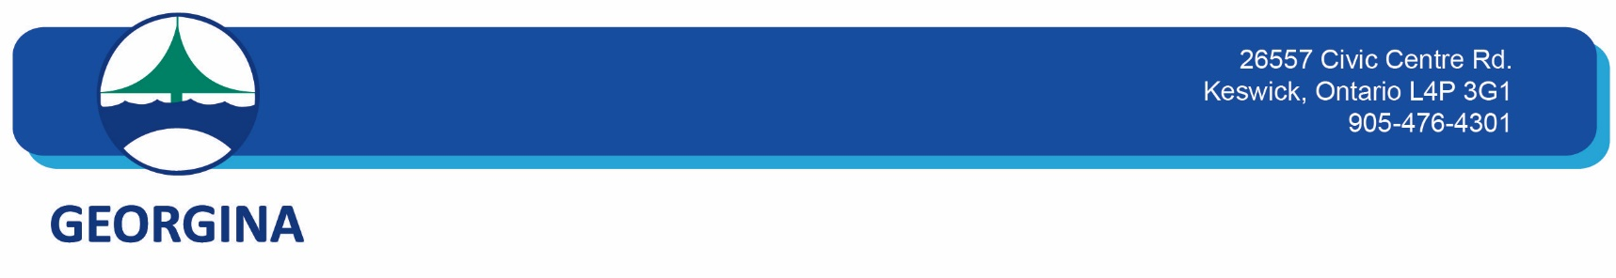

**Community Services**

**Service Disruption Name**

MURC Aquatic Program Cancellation: May 2, 2025, from 6:45 pm – 8:30 pm

**Service Disruption Type**

Programming Disruptions

**Date**

Friday, May 2, 2025, 6:45 pm – 8:30 pm

**Description**

MURC Aquatic Programs cancelled on May 2, 2025, from 6:45 pm – 8:30 pm, for Youth Week programs. This includes the following program(s):

Public Swim, from 6:45 pm – 8:30 pm

All regular scheduled programming will resume on May 3, 2025, at 9:00am.