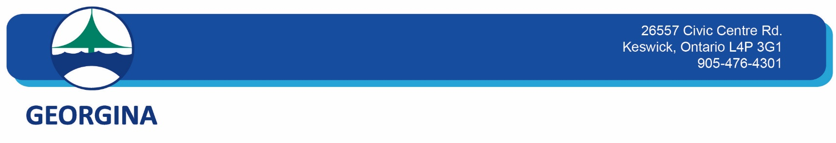

**Community Services**

**Service Disruption Name**

MURC Aquatic Program Cancellation: August 15, 2025, from 1:00 pm – 9:00 pm

**Service Disruption Type**

Programming Disruptions

**Date**

Friday, August 15, 2025, 1:00 pm – 9:00 pm

**Description**

MURC Aquatic Programs cancelled on August 15, 2025, from 1:00 pm – 9:00 pm, for our sessional Staff Training. This includes the following program(s):

Accessibility Swim, from 1:00 pm - 2:30 pm

Public Swim, from 5:30 pm – 7:30 pm

Lane Swim, from 7:30 pm – 9:00pm

Therapy Pool Swim, from 7:30 pm – 9:00pm

All regular scheduled programming will resume on August 16, 2025, at 9:00am.